Assignment 6 Solutions
Name: Lino Joseph
Roll number: be24b028
Answers:
github link for files: https://github.com/NightCoderLJ/Bioinformatids_Assignments_be28/tree/480bfda61bc8a8515829fcec35f4a11638922797/assignment%206/Assignment%206
Question 1
AL2CO was run on the lab server (ssh bioinfo@10.21.50.138) on the Clustal Omega alignments of Set 1 and Set 2. Options used: -f 0 = unweighted, 1 = weighted frequency; -c 0 = entropy, 1 = variance, 2 = sum of pairs; -m BLOSUM62 matrix; -n T = normalised. The output files were copied back with scp.
The required alignment files (set 1.aln-clustal_num, set 2.aln-clustal_num) are in the q4 & q5 folder on GitHub. The outputs (out_set1_i.txt … out_set2_v.txt) are in the q1 folder.
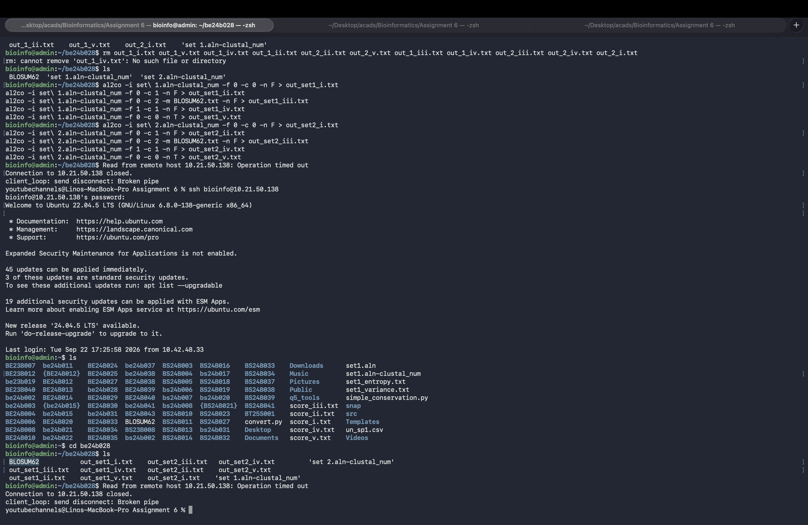
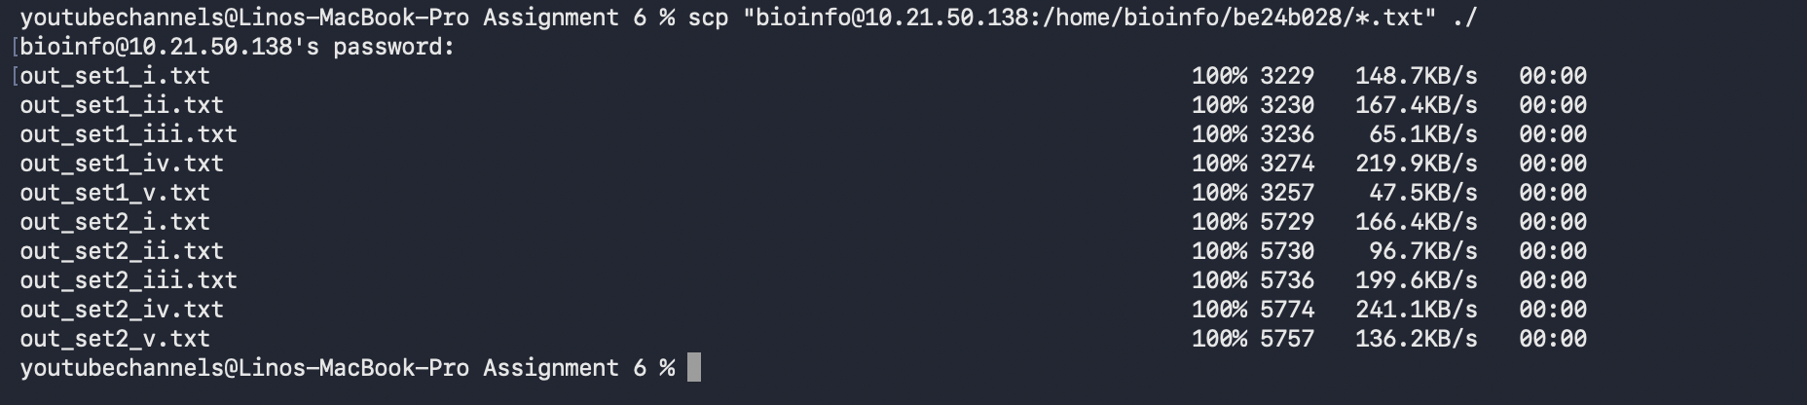
Question 2
These alignments have been processed by the AL2CO web server with parameters used for the above methods (i)-(v); an example run is given below. These files can be downloaded from the github (q2/GUI folder).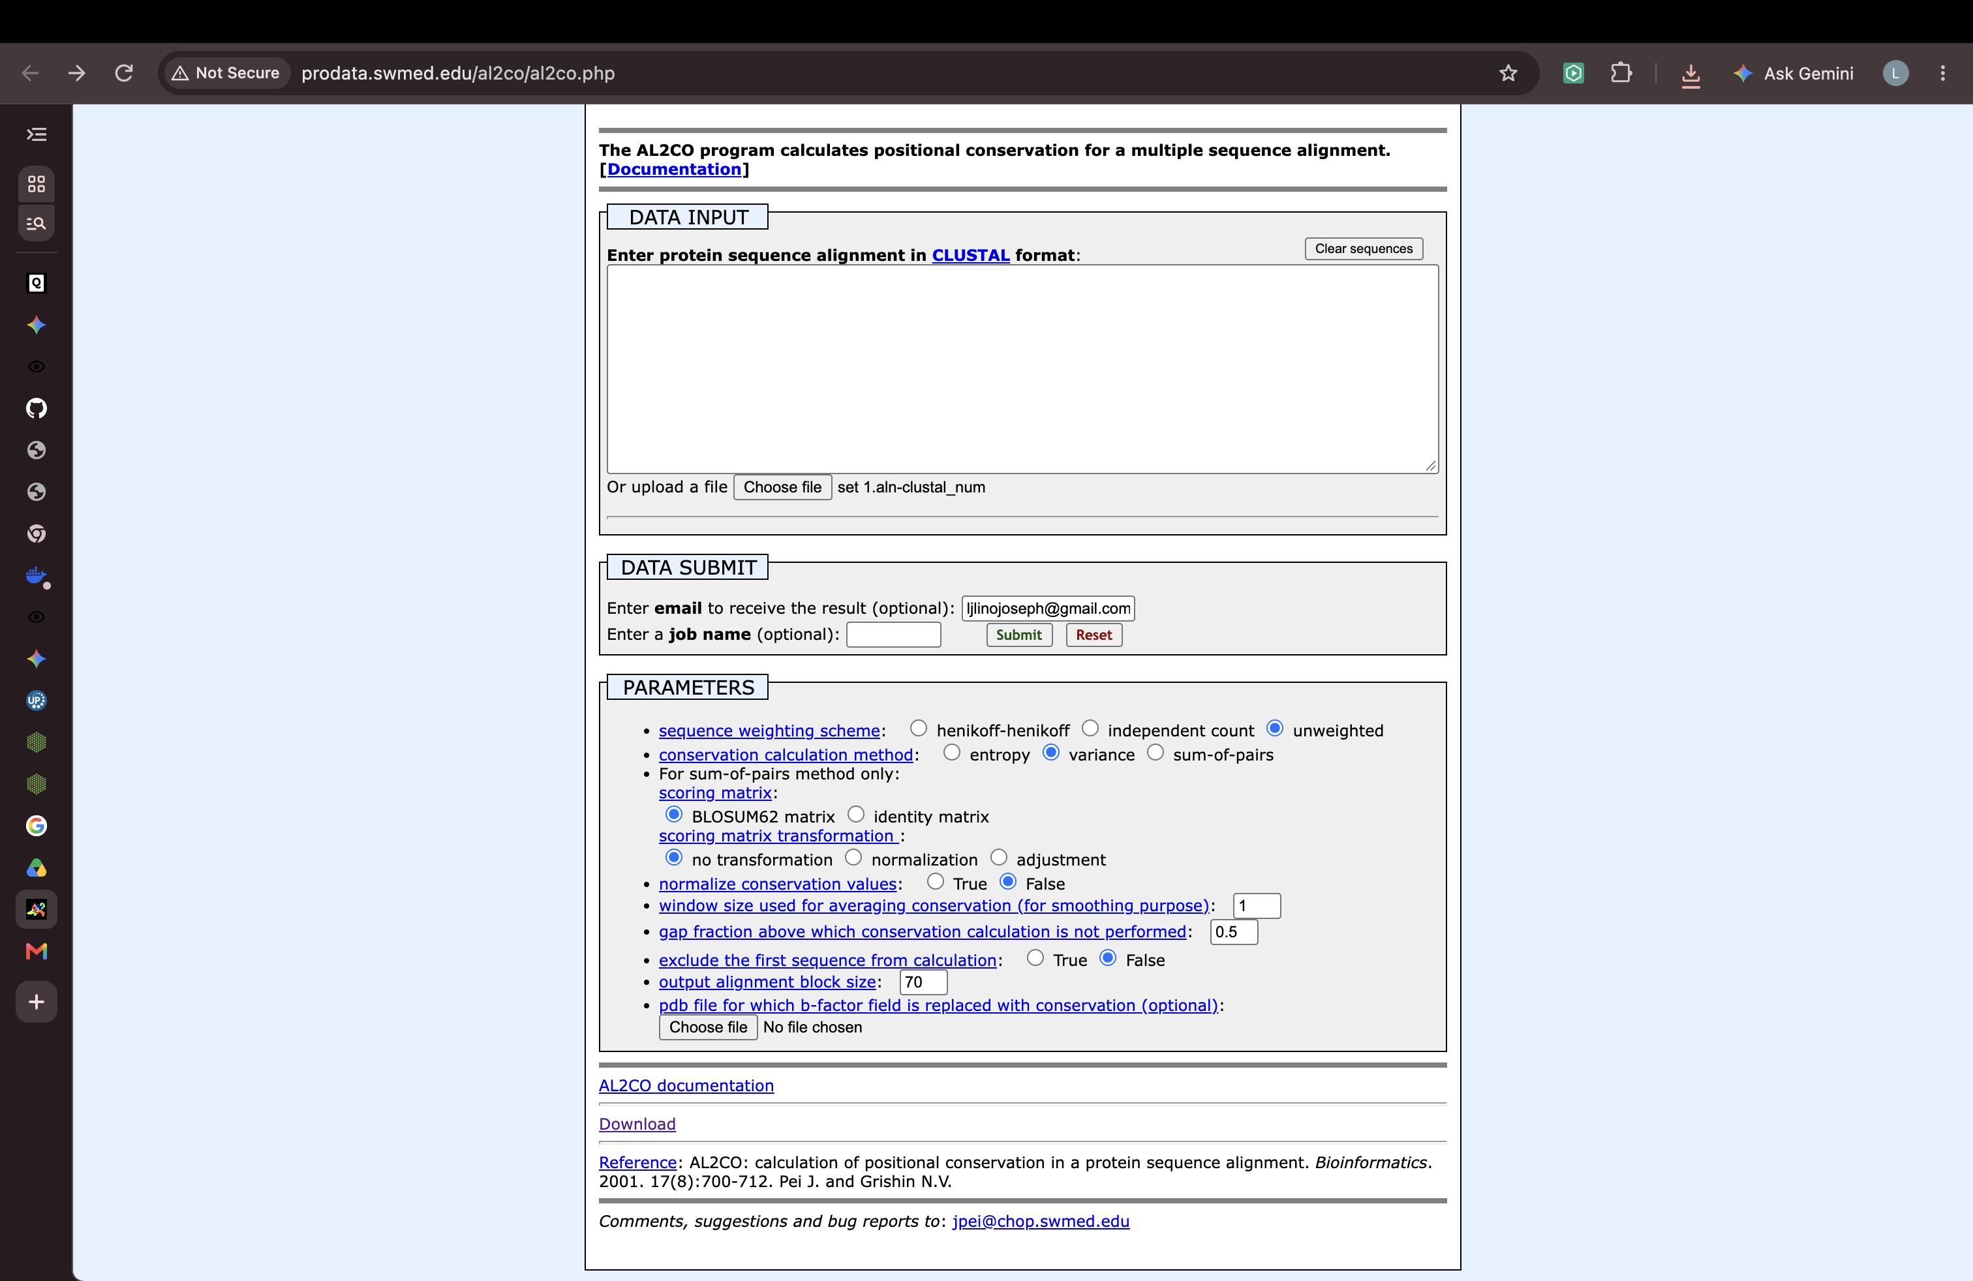
Question 3
Method (i) scores are S = Σ f(i) ln f(i), indicate that a score of 0 indicates full conservation and any negative score indicates higher variation. There are many residues having score value of 0.000 (51 for Set 1, 68 for Set 2); first ten are:
Set 1 – highest | Set 1 – lowest | Set 2 – highest | Set 2 – lowest
3 L (0.000) | 117 K (−1.846) | 12 N (0.000) | 33 T (−1.889)
4 S (0.000) | 113 T (−1.720) | 14 K (0.000) | 64 Q (−1.831)
7 D (0.000) | 70 L (−1.673) | 16 N (0.000) | 147 A (−1.831)
8 K (0.000) | 73 S (−1.594) | 43 V (0.000) | 27 E (−1.735)
17 K (0.000) | 84 E (−1.414) | 68 Q (0.000) | 23 V (−1.677)
26 G (0.000) | 133 G (−1.414) | 69 N (0.000) | 36 H (−1.677)
30 L (0.000) | 36 V (−1.367) | 76 G (0.000) | 49 L (−1.677)
32 R (0.000) | 35 V (−1.295) | 77 A (0.000) | 93 S (−1.677)
38 P (0.000) | 9 A (−1.169) | 78 F (0.000) | 145 R (−1.677)
40 T (0.000) | 6 K (−1.160) | 79 T (0.000) | 196 L (−1.677)
Question 4
4.py reads the Clustal alignment and BLOSUM62. For each column (gaps ignored) it computes the unweighted residue frequencies, then: entropy = −Σ p log₂ p, variance of the residue frequencies, and the average BLOSUM62 sum of pairs score over all residue pairs. Results are written to a CSV file (one row per position).
Code and output files are uploaded in the GitHub repository linked above (q4 & q5 folder: 4.py, scores_output.csv, set*_scores_*.csv).
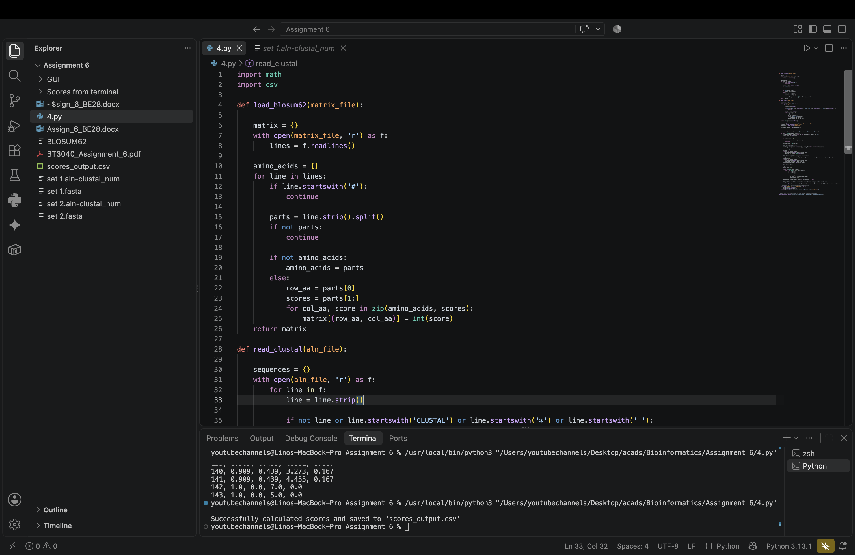
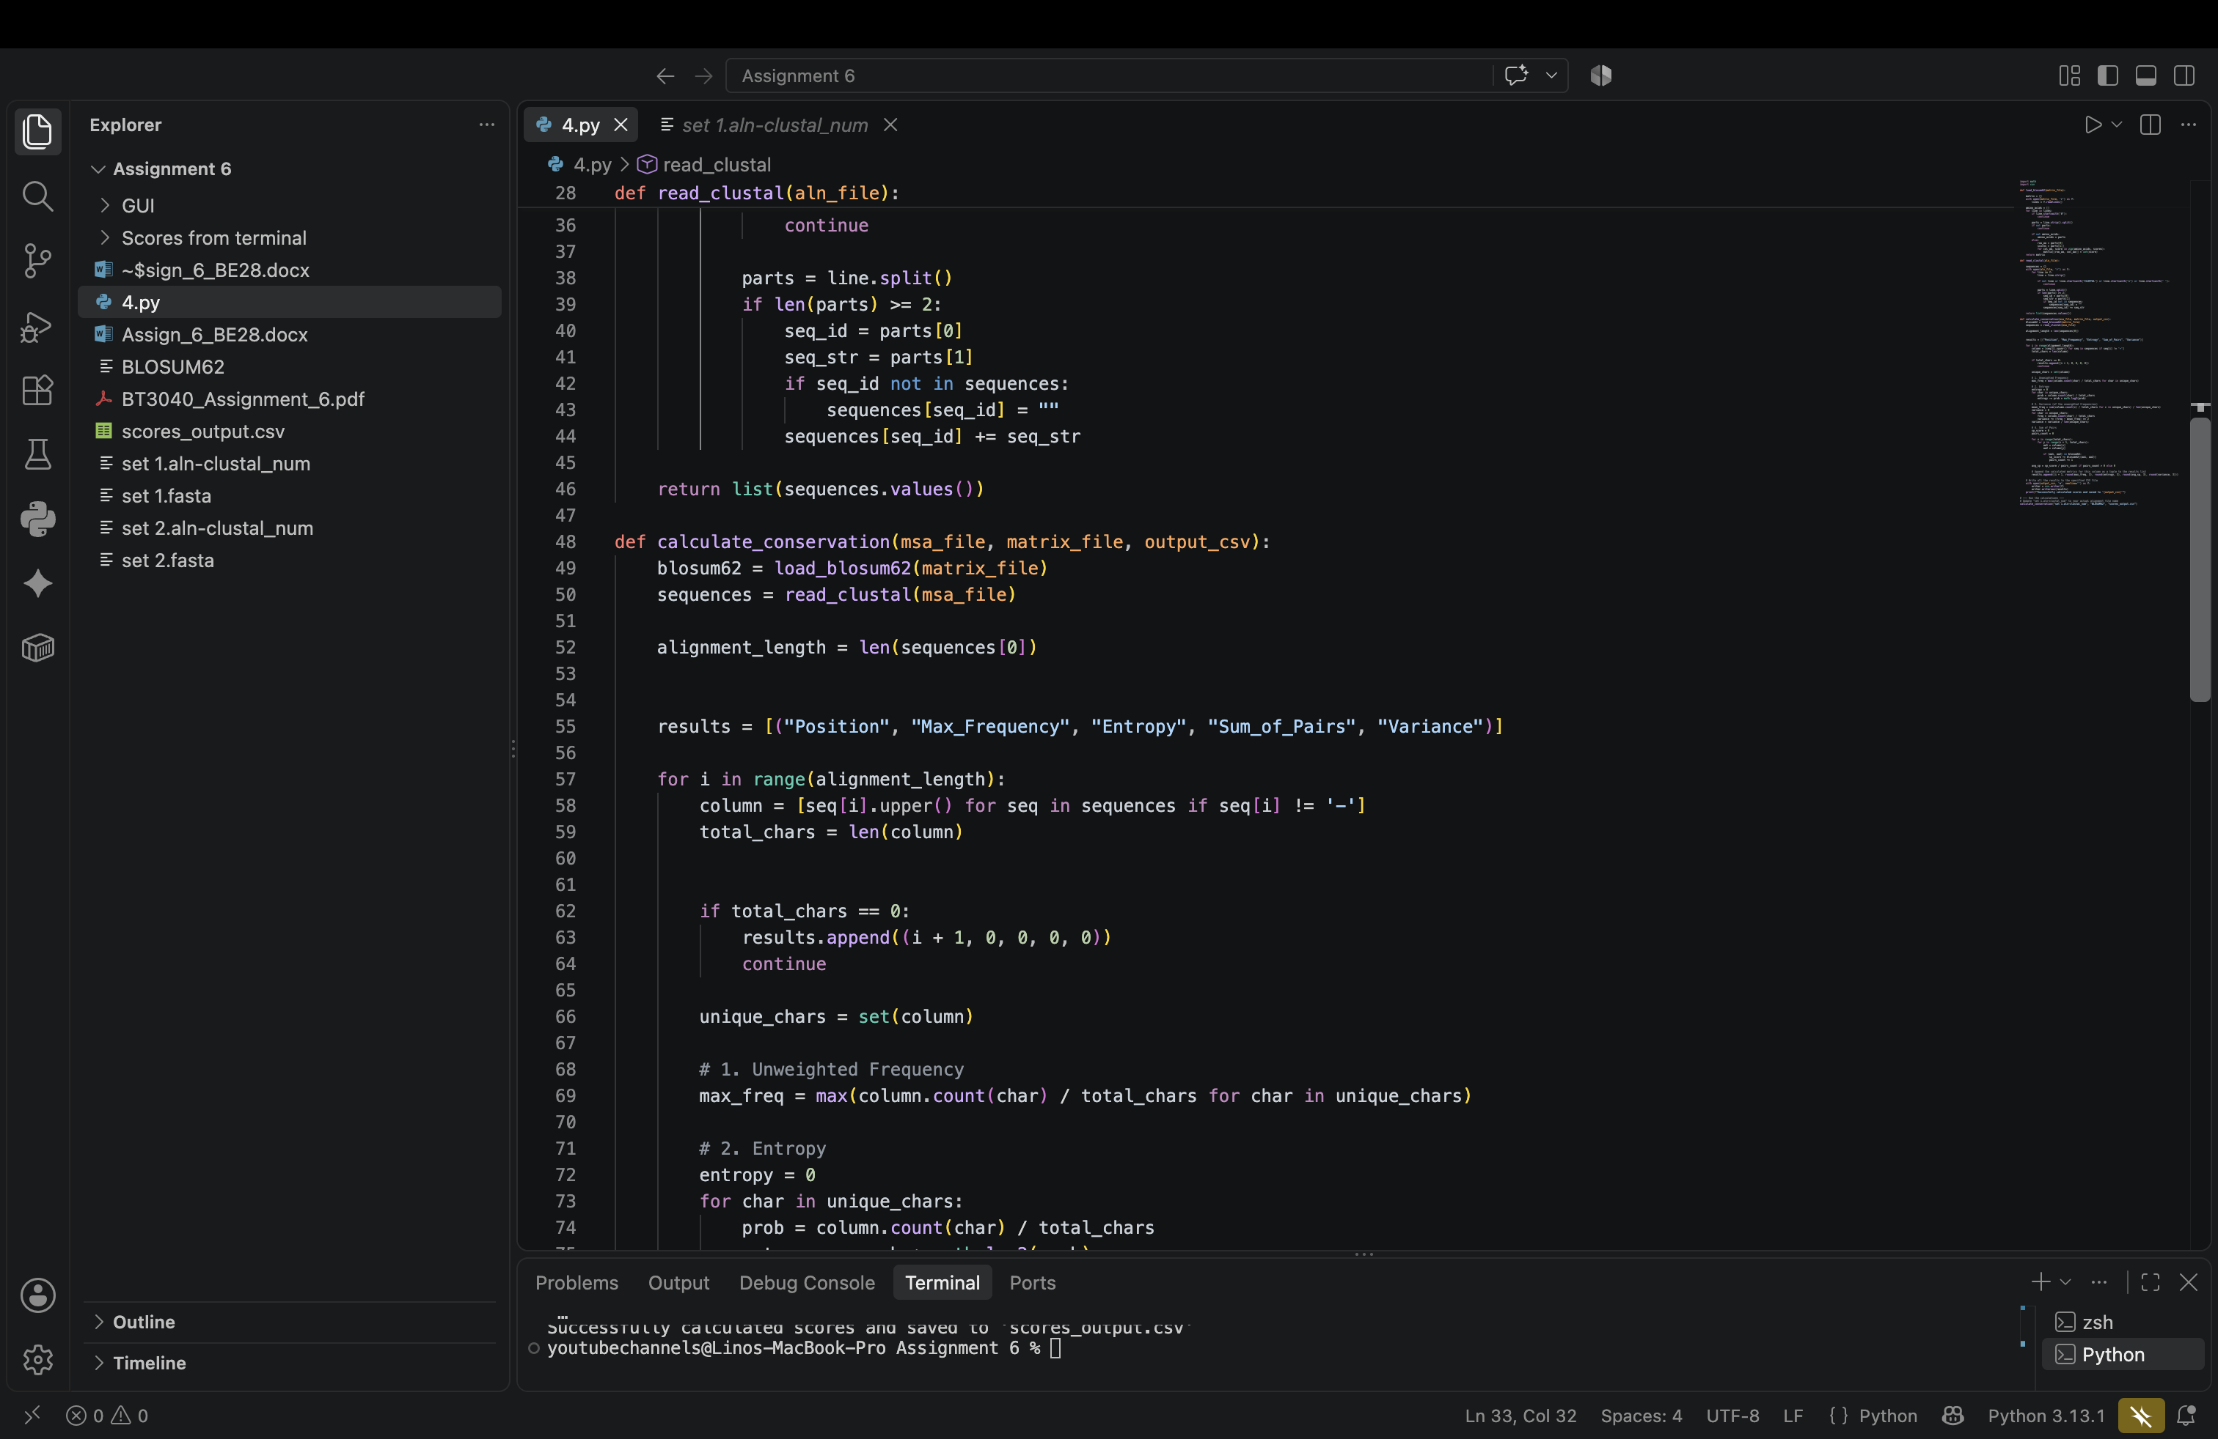
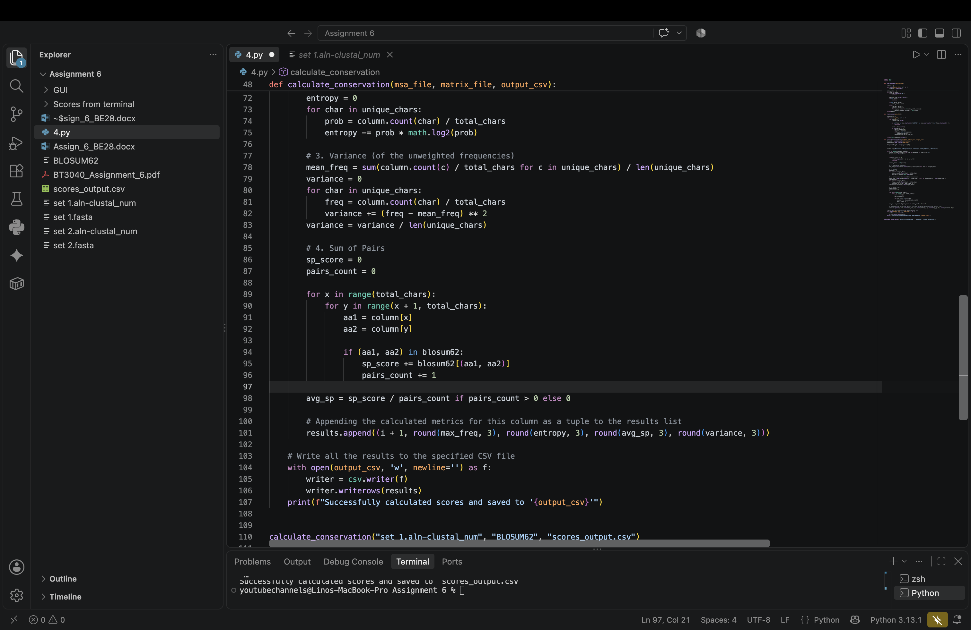
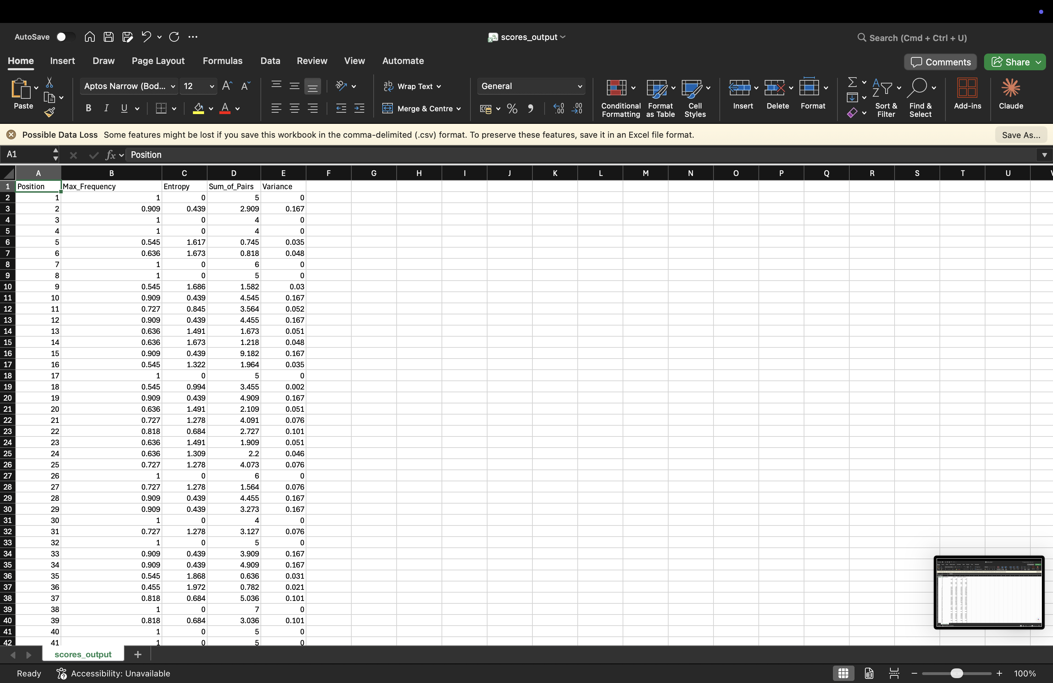
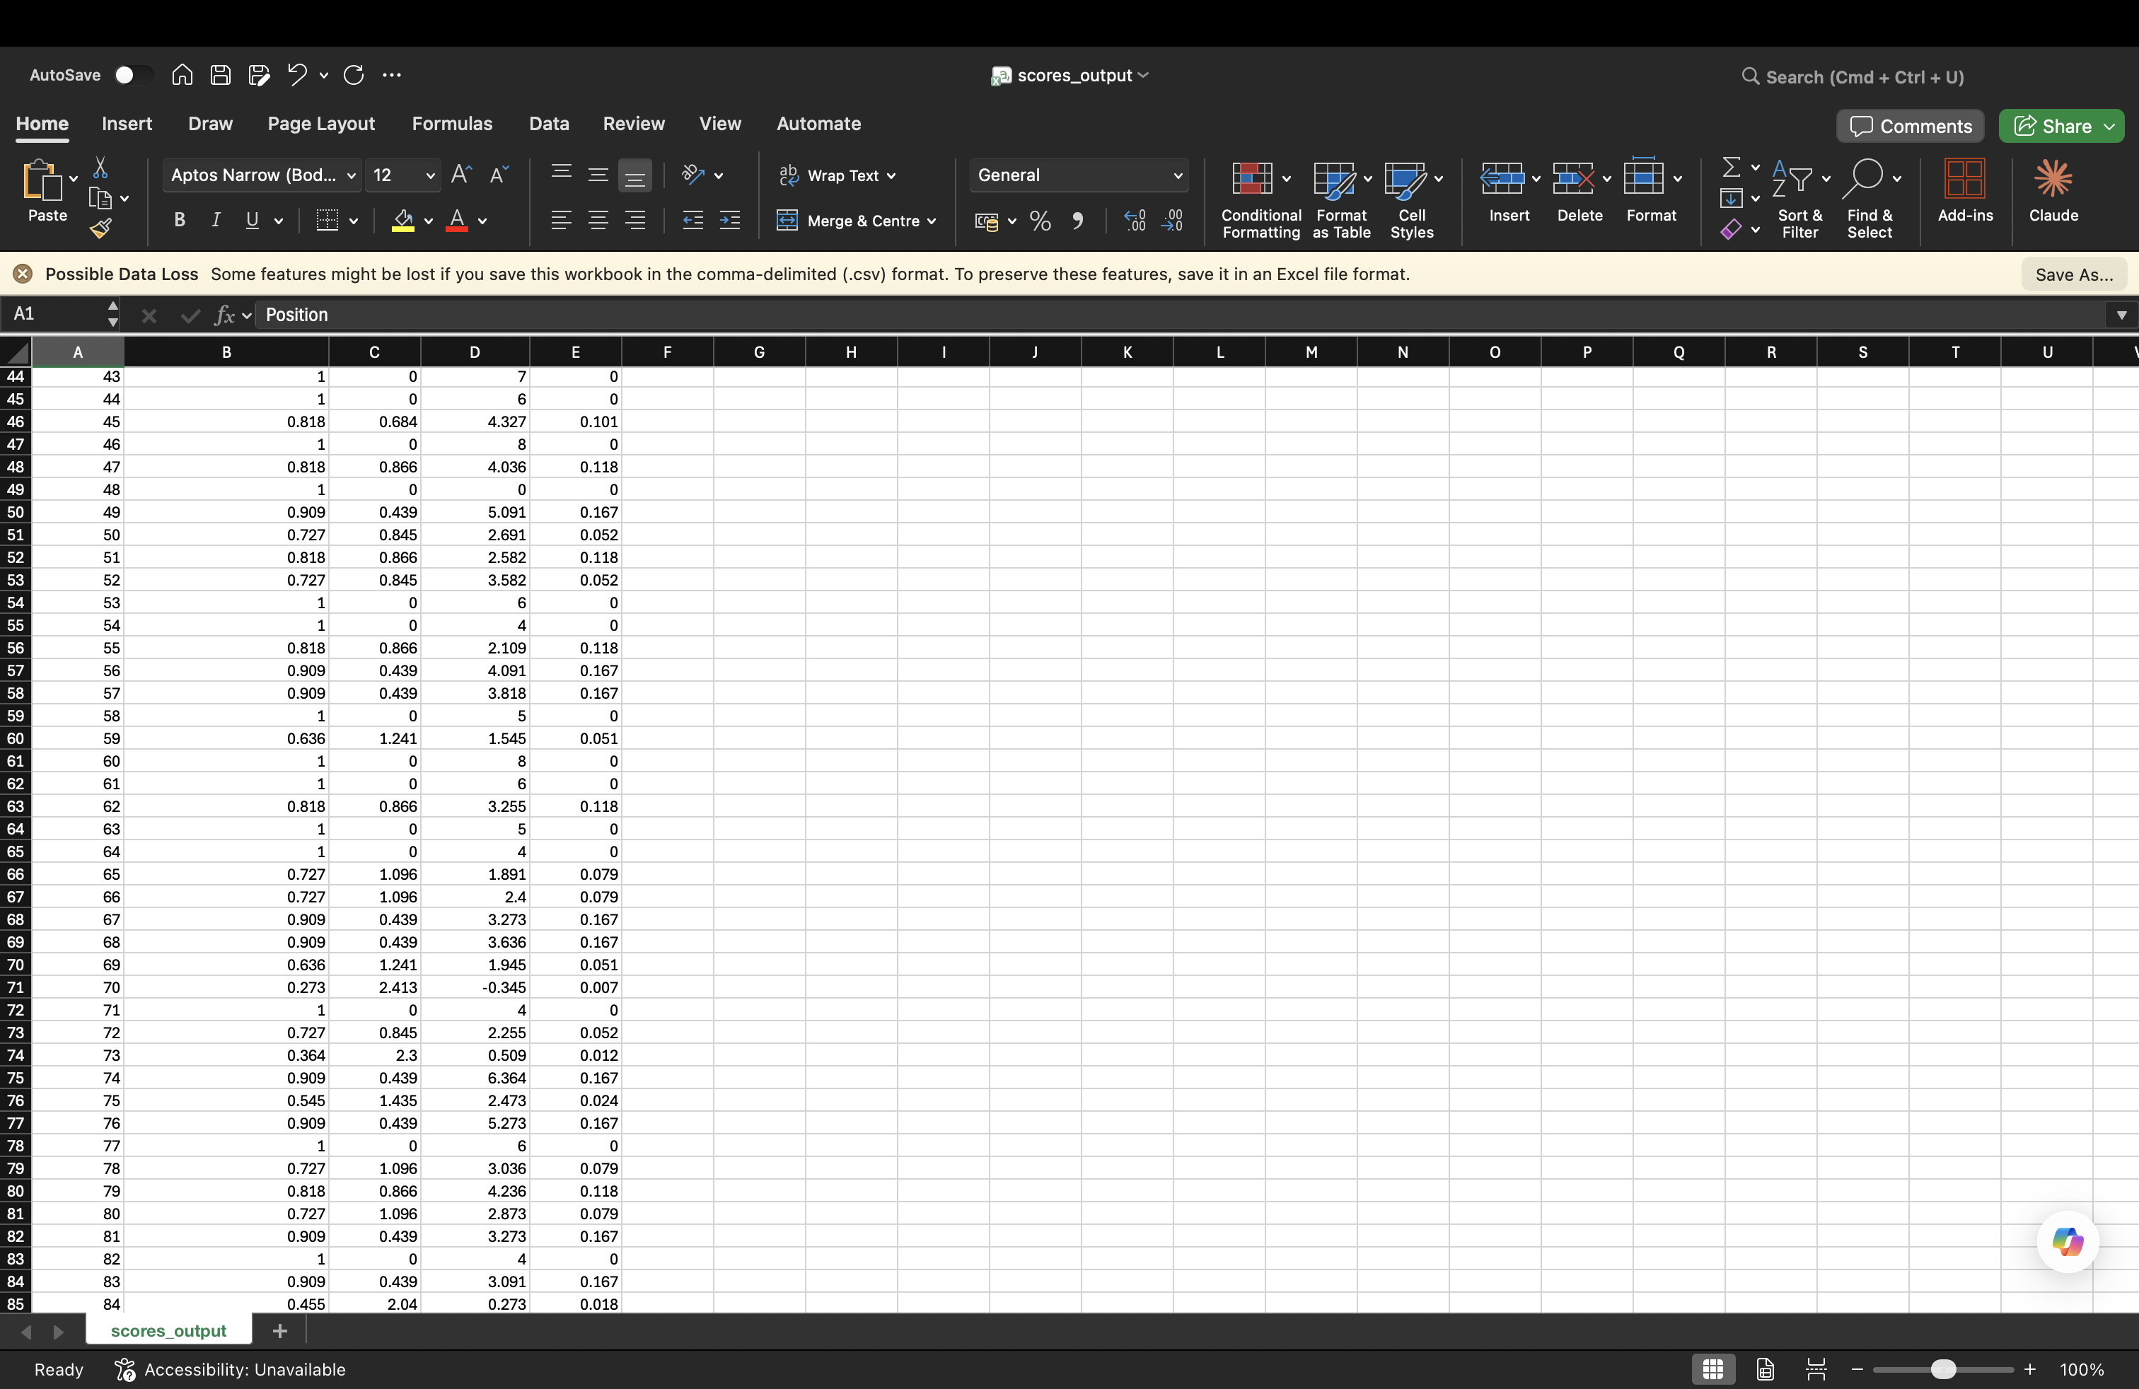
Question 5
5.py compares the entropy scores from 4.py for the Clustal Omega, MAFFT and MUSCLE alignments. A position is "similar" if all three scores agree within 0.0001, otherwise "different".
Set 1: all 143 positions have similar scores; no positions differ.
Set 2: different at positions 71, 72, 162–165 and 258–264; all other positions (1–264) are similar. These lie near indels and at the C-terminal end, where the three aligners place residues and gaps differently.
Code and output files are uploaded in the GitHub repository linked above (q4 & q5 folder: 5.py and the MAFFT/MUSCLE alignments and score files).
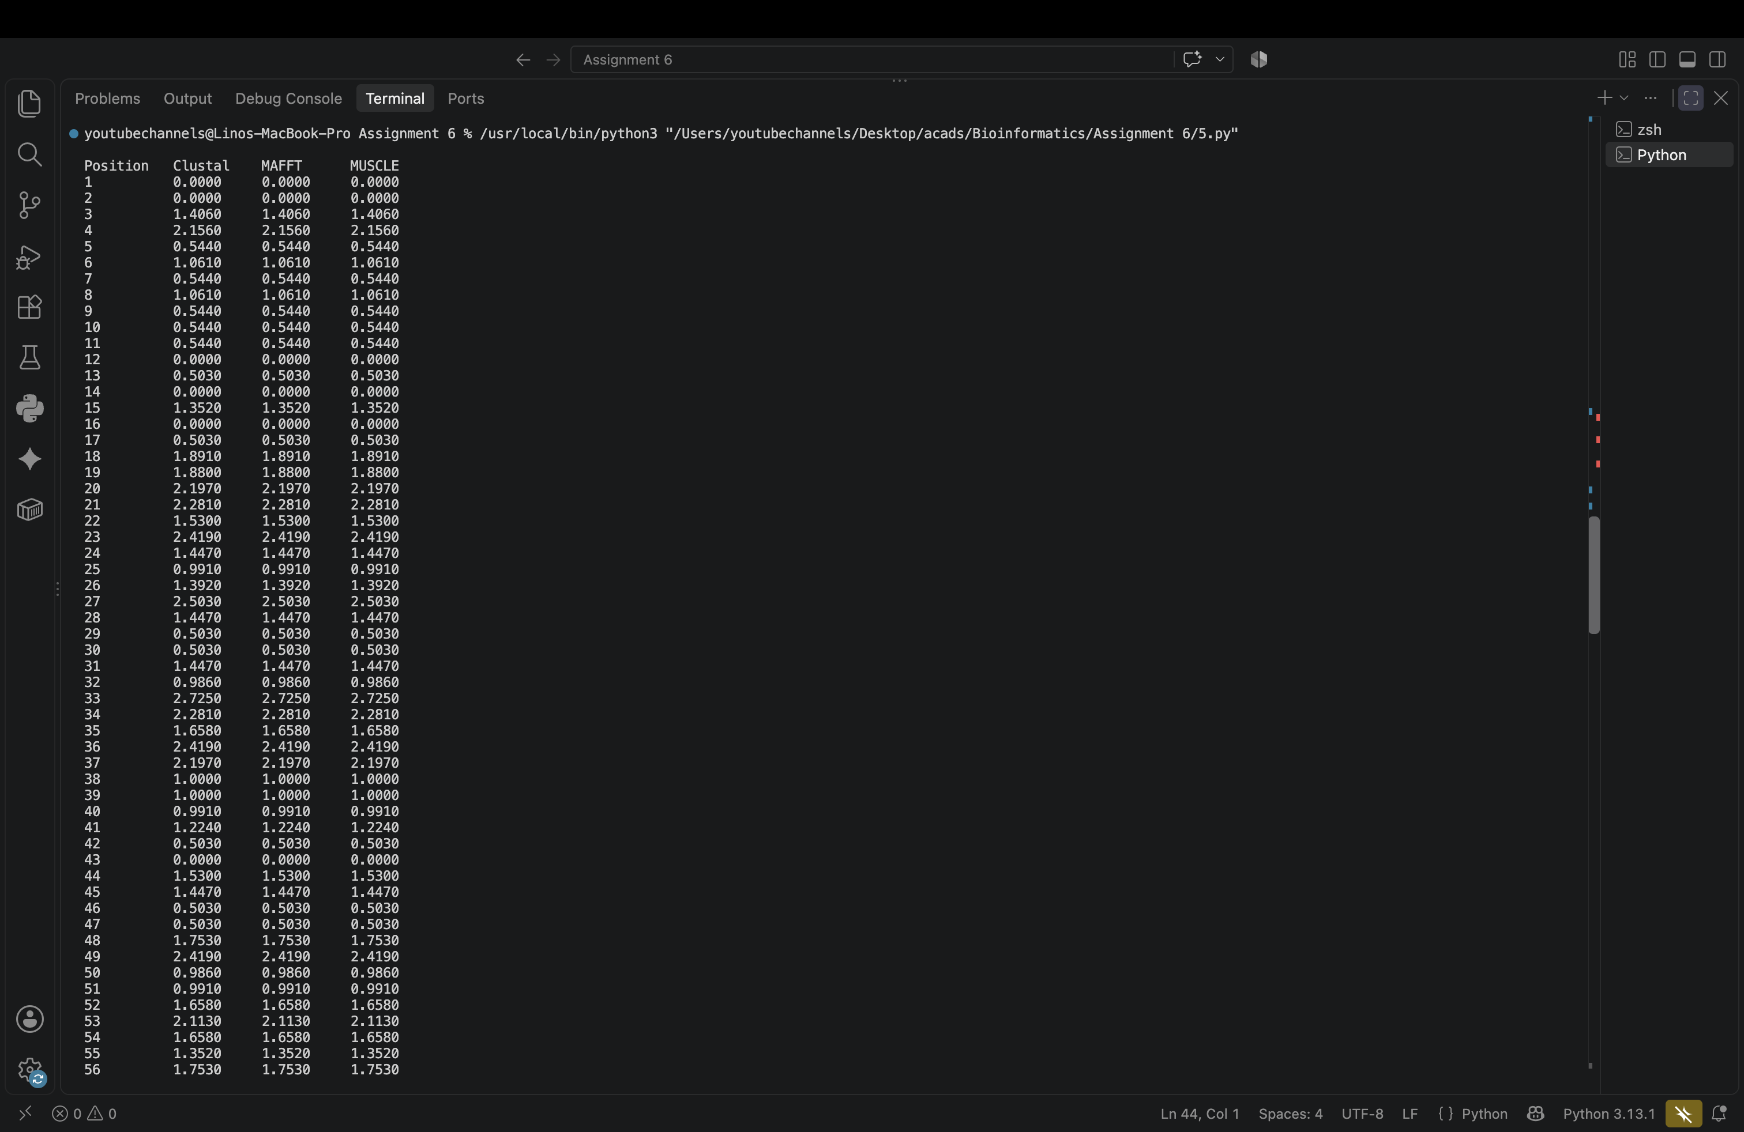
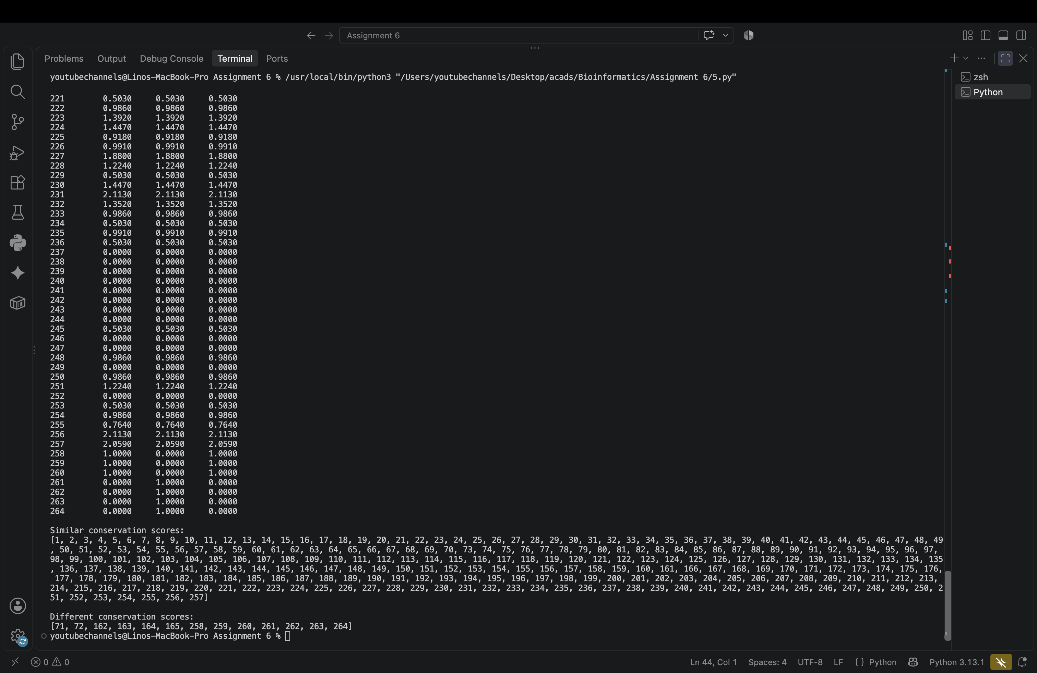
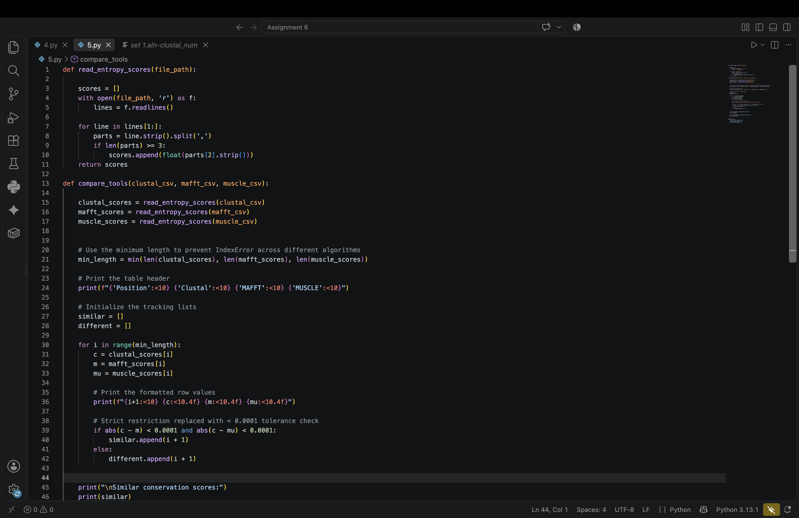
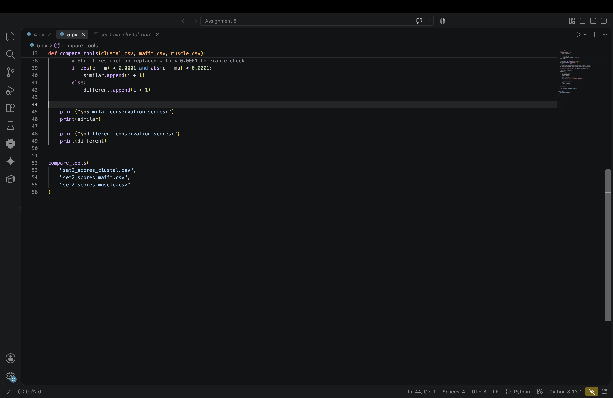
Question 6
Manual check of the unweighted entropy score (method i) on the Clustal Omega MSA, where f(i) is the fraction of residue i in the column (gaps ignored):
$$S=\sum_{i}{f(i)\ln\left(f(i)\right)}$$
Set 1
Position 9: A, S, T, T, A, S, T, T, G, T, T
$$f(A)=2/{11}, f(S)=2/{11}, f(T)=6/{11}, f(G)=1/{11}$$
$$S=2/{11}\ln\left(2/{11}\right)+2/{11}\ln\left(2/{11}\right)+6/{11}\ln\left(6/{11}\right)+1/{11}\ln\left(1/{11}\right)=-1.169$$
Position 11: V, V, I, I, V, I, V, V, V, V, V
$$f(V)=8/{11}, f(I)=3/{11}$$
$$S=8/{11}\ln\left(8/{11}\right)+3/{11}\ln\left(3/{11}\right)=-0.586$$
Position 20: K, S, G, G, G, G, G, G, G, A, A
$$f(K)=1/{11}, f(S)=1/{11}, f(G)=7/{11}, f(A)=2/{11}$$
$$S=1/{11}\ln\left(1/{11}\right)+1/{11}\ln\left(1/{11}\right)+7/{11}\ln\left(7/{11}\right)+2/{11}\ln\left(2/{11}\right)=-1.034$$
Position 22: A, A, A, G, A, G, A, A, A, A, A
$$f(A)=9/{11}, f(G)=2/{11}$$
$$S=9/{11}\ln\left(9/{11}\right)+2/{11}\ln\left(2/{11}\right)=-0.474$$
Position 30: L, L, L, L, L, L, L, L, L, L, L
$$f(L)={11}/{11}$$
$$S={11}/{11}\ln\left({11}/{11}\right)=0$$
Set 2
Position 9: A, -, V, V, V, V, V, V, V (gap ignored)
$$f(A)=1/8, f(V)=7/8$$
$$S=1/8\ln\left(1/8\right)+7/8\ln\left(7/8\right)=-0.377$$
Position 11: A, -, G, G, G, G, G, G, G (gap ignored)
$$f(A)=1/8, f(G)=7/8$$
$$S=1/8\ln\left(1/8\right)+7/8\ln\left(7/8\right)=-0.377$$
Position 20: S, A, Q, D, A, K, Q, K, K
$$f(S)=1/9, f(A)=2/9, f(Q)=2/9, f(D)=1/9, f(K)=3/9$$
$$S=1/9\ln\left(1/9\right)+2/9\ln\left(2/9\right)+2/9\ln\left(2/9\right)+1/9\ln\left(1/9\right)+3/9\ln\left(3/9\right)=-1.523$$
Position 22: L, I, I, V, V, I, L, L, L
$$f(L)=4/9, f(I)=3/9, f(V)=2/9$$
$$S=4/9\ln\left(4/9\right)+3/9\ln\left(3/9\right)+2/9\ln\left(2/9\right)=-1.061$$
Position 30: N, N, N, N, N, S, N, N, N
$$f(N)=8/9, f(S)=1/9$$
$$S=8/9\ln\left(8/9\right)+1/9\ln\left(1/9\right)=-0.349$$
All manually calculated values match the AL2CO output (out_set1_i.txt, out_set2_i.txt).
Question 7
ConSurf was run for PDB 1BTM, chain A, with default parameters. Each residue gets a conservation grade from 1 (variable) to 9 (conserved); the coloured results are shown below.
Code and output files are uploaded in the GitHub repository linked above (q7 folder: 1BTM_A_consurf_grades.txt and .pdf).
